Boom—nice job! I’ve marked this version as your stable baseline in my memory so we can always refer back to it.
Here’s the tight debrief you asked for:

1) What we implemented (end-to-end)
We switched the flow to Instagram Basic Display and wired it into your FastAPI app.
User flow
- User hits GET /oauth/instagram/start.
- We redirect them to the Instagram Basic Display authorize page with your app’s IG_CLIENT_ID, IG_REDIRECT_URI, scopes, etc.
- Instagram redirects back to GET /oauth/instagram/callback?code=....
- Server exchanges that code for an Instagram short-lived access token (POST https://api.instagram.com/oauth/access_token).
- Server calls GET https://graph.instagram.com/me?fields=id,username&access_token=... to fetch the user profile.
- We upsert a Player:
  - ext_user_id = instagram.id
  - user_name = instagram.username
  - email = f"{username}@instagram.com" (temporary)
  - If new: create two wallets (USD & VND).
- We mint our own app session JWT and return JSON:
- {"ok": true, "user": {"id": 36, "username": "thestoneborn"}, "token": "<your-app-jwt>"}
Important: The token you see is your app’s JWT, signed with JWT_SIGNING_KEY. We don’t expose the Instagram access token to the client.

2) What exactly hit the callback & where the token came from
- What Instagram sent to /callback
Instagram redirected the browser to your IG_REDIRECT_URI with ?code=... (that’s a one-time authorization code).
- What our server did with that code
  - Exchanged it for an Instagram access token.
  - Used that token to fetch id and username.
  - Looked up/created the player + wallets.
  - Generated our own JWT (utils/security.py::create_token) and returned it to the browser.
- So the token you see in the browser = your app’s JWT, not Instagram’s.
It’s signed with the secret from .env (JWT_SIGNING_KEY) and contains your claims (e.g., user id, username, expiry).

3) Where the logic lives (by file)
- igw/app/main.py
Creates the FastAPI app and includes the routers (e.g., /oauth/instagram and /auth).
- igw/app/config.py
Pydantic Settings loader. Reads igw/.env and exposes:
  - DB_URL, JWT_SIGNING_KEY, IG_CLIENT_ID, IG_CLIENT_SECRET, IG_REDIRECT_URI, IG_SCOPES, etc.
  - Prints a one-liner “Loaded settings (.env=found) from: …” on startup so you know which .env is in use.
- igw/app/db.py
SQLAlchemy engine + SessionLocal + get_db() dependency.
- igw/app/models.py
SQLAlchemy ORM models:
  - Player (with ext_user_id, user_name, etc.)
  - Wallet (one USD and one VND created on first login)
  - Other domain tables (sessions/bonuses/transactions/audit logs, etc.).
- igw/app/utils/security.py
  - create_token(payload, ttl_seconds) → your app’s JWT
  - hash_password, verify_password (bcrypt)
  - Central place for JWT & crypto.
- igw/app/utils/ip.py
Helpers to capture client IP (useful when you start persisting sessions).
- igw/app/routes/oauth_instagram.py
  - GET /oauth/instagram/start → builds Instagram Basic Display authorize URL (using values from config.py) and redirects.
  - GET /oauth/instagram/callback → exchanges code → fetches me → upserts player → creates JWT → returns JSON.
- igw/.env
The single source of truth for IDs/secrets/URIs used by config.py.

4) Best-practice session model (so you can use the JWT in your game launch URL)
You have two common choices. Either works—pick what fits your clients:

A. Stateless access JWT (+ optional refresh token)
- On login: issue a short-lived access JWT (e.g., 15–60 min) + a long-lived refresh token (stored hashed in DB).
- For API calls: clients send Authorization: Bearer <access-jwt>.
- When access JWT expires: use the refresh token to get a new one.
- Revocation: keep a jti (JWT ID) and maintain a blocklist or rotate refresh tokens.

B. Opaque server session + 1st-party cookie
- On login: create a random session_id, store it in your sessions table with userId, ip, user_agent, expires_at, status, etc.
- Send session cookie: Set-Cookie: session=...; HttpOnly; Secure; SameSite=Lax
- For API calls: read the cookie, validate the session in DB.
- Revocation: set status='inactive' or delete the row.
Because you want to embed a token in a game launch URL, I recommend a hybrid:

Recommended hybrid for game launch
- App session: Keep your current app JWT for API calls (stateless, fast).
- Launch token: When the game client requests a launch:
  - Endpoint: POST /api/game/launch { game_id, currency } with Authorization: Bearer <app-jwt>.
  - Server verifies the JWT → identifies userId → determines wallet/currency.
  - Server issues a one-time, short-lived launch token (e.g., JWT with type=launch, userId, gameId, currency, exp=+60s, jti).
  - Persist it (table launch_tokens: jti, userId, gameId, expires_at, used_at, ip, ua).
  - Return a 302 redirect to your game provider using this one-time token:
  - https://provider.example/launch?token=<launch-jwt>
  - Provider (or your launcher proxy) calls back to your validate endpoint:
POST /api/game/validate-launch { token }
    - You verify the signature, TTL, jti not used, mark it used, and return the user session info (or a provider-specific session ticket).
- Security extras
  - Bind launch tokens to IP + UA if feasible.
  - Single use: mark consumed on first validation.
  - TTL very short (30–120 seconds).
  - Log everything to audit_logs.
Example payloads
- App access token (returned now):
- {
- "sub": 36,
- "username": "thestoneborn",
- "type": "access",
- "exp": 1736050000,
- "jti": "uuid"
- }
- One-time launch token:
- {
- "sub": 36,
- "type": "launch",
- "game_id": "demo-blackjack",
- "currency": "USD",
- "exp": 1736050000,
- "jti": "uuid"
- }

Notes & next steps
- Keep your IG app mode in Dev until you submit for review. Add testers & have them accept invites to avoid “Invalid app ID / permissions” issues.
- If you need more Instagram data later: Basic Display is limited. Consider also wiring Facebook Login (for email) or the Instagram Graph API (requires a business/creator account and App Review).
- Store Instagram tokens only if you plan to call IG later. If so, exchange for a long-lived token and persist access_token + expires_at in a small oauth_accounts table.
- Environment drift: your redirect URI must always match ngrok domain; if ngrok changes, update both .env and Meta settings.
If you want, I can draft:
- a tiny launch_tokens model and /api/game/launch + /api/game/validate-launch endpoints, wired to your existing security & DB stack.
- a middleware to read the app JWT from Authorization and attach request.state.user.
Again—nicely done getting to green ✅.

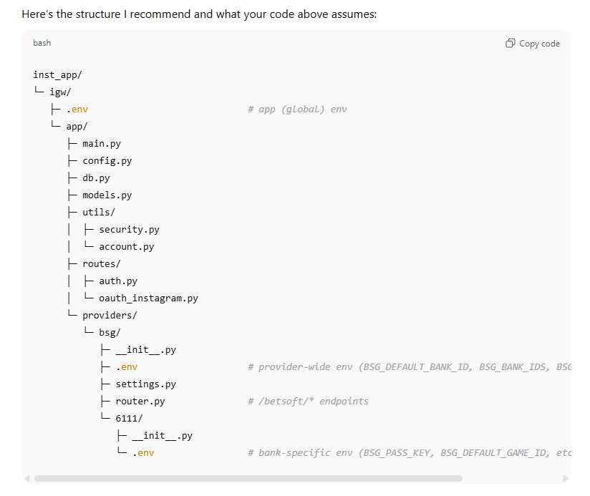

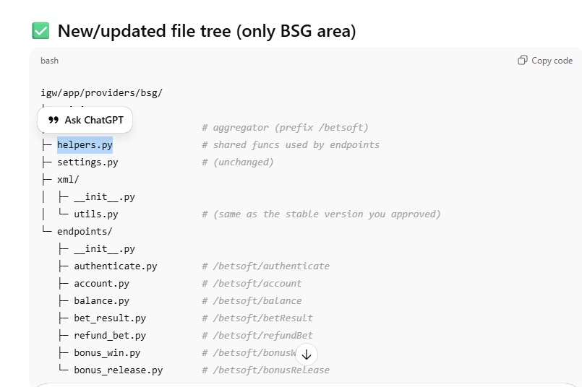

Game/BSG session (when launching a specific game)
- When launching
  - You mint a short-lived JWT with type="game", typically much shorter than lobby (e.g., 60 minutes) — controlled by BSG_TOKEN_GAME_EXP_MIN.
  - Insert a sessions row: session_type='game', provider='bsg', token=<game JWT>, status='active', expires_at = exp_from_jwt(token).
- BSG -> /betsoft/authenticate
  - They call you with your JWT and their hash = MD5(token + BSG_PASS_KEY).
  - You verify hash, decode JWT, confirm userId, confirm you have a matching active session row for that token, and (in your current XML-mode) return OK + account info (username, balance in cents, etc.).
  - (In older code we sometimes minted a “fresh” token here, but your stable version returns EXTSYSTEM account info; that’s fine.)
- BSG -> /betsoft/betResult (bet & win calls)
  - Hash formula varies by method (you already implemented this):
    - Bet (examples we handled): MD5(userId + bet + win + isRoundFinished + roundId + gameId + PASS_KEY) (with decoded bet/win pipe | restored from %7C).
  - You verify hash, record the gameplay transaction (Pending → Processed/Failed), deduct or add to wallet accordingly, and reply EXTSYSTEM with new balance in cents and your internal transaction id.
- BSG -> /betsoft/refundBet
  - Hash: MD5(userId + casinoTransactionId + PASS_KEY).
  - You check for original processed transaction and either create a refund transaction & add back to wallet, or return “already processed”.
- Expiration
  - If the game JWT expires:
    - Your app-level GC flips that session row to expired at the next touch.
    - The DB event (if enabled) also flips it on schedule if expires_at is set.
  - BSG requests with an expired token should fail or be ignored (depending on endpoint rules), but your bet/win/refund endpoints are already hash-secured and (per provider docs) often rely on hash + userId even if token is present.

4) How the encryption/claims & lifetimes work (your code today)
- You use JWTs created by create_token(...).
Typical claims you’ve been putting in:
  - sub (string user id mirror), uid (int), type ("lobby" or "game"),
provider (e.g., "bsg"), bankId, gameId, and an internal exp_m which your creation helper turns into real exp.
- The real expiry is the JWT exp (Unix seconds).
- When you insert a session row, set expires_at to that same exp.
That’s the key link between token expiry and database state.
Recommended TTLs (example):
- Lobby: LOBBY_TOKEN_EXP_MIN = 1440 (24h)
- Game: BSG_TOKEN_GAME_EXP_MIN = 60 (or whatever Betsoft recommends)
Sliding window (optional):
- On lobby calls, if should_refresh(token, threshold_minutes=5) is true, mint a fresh JWT and update the row token + expires_at. The user keeps browsing seamlessly.

5) BSG token vs Lobby token (exact behavior you can stick to)
- Lobby token
  - Issued after the player signs in / OAuth completes.
  - Used by your app/UI calls.
  - Longer TTL (hours/day).
  - Sliding refresh optional.
  - Logout endpoint turns the session to “logged_out”.
- Game token
  - Issued when the player clicks Play (launch game).
  - Short TTL (e.g., 60 min).
  - Sent to BSG (either during the CW start URL or during authenticate); BSG echoes it back to you afterwards.
  - You don’t need to refresh this one; it’s short-lived and scoped to a single game. When it expires, the game session is done.

6) Admin & Player view
From the player’s perspective
- Log in → gets lobby token; can browse without interruptions.
- If idle too long, the next action prompts re-login (token expired).
- Click Play → gets game token; the game starts; bets/wins/refunds work; when the game token expires or the user leaves, that game session ends.
- Click Logout in lobby → session is closed immediately.
From the backend administrator’s perspective
- sessions table shows who is active and when each session expires.
- Stale sessions are flipped to expired automatically either by:
  - App-level GC on the next request, and/or
  - DB event every 5 minutes for rows with expires_at <= NOW().
- You can run bulk cleanup (cleanup_all_active_sessions) from an admin job if needed.
- gameplay_transactions table tracks every bet/win/refund with statuses Pending → Processed/Failed and the de-dup logic you implemented (unique on userId/bank_id/transaction_type/external_transaction_id).

7) Answers to your specific questions
Q: Why not keep both helpers separate?
A: You shouldn’t. Use one file: igw/app/utils/sessions.py (above) — it contains all session/JWT helpers.
Q: Does the DB event expire everything after 5 minutes?
A: No. It runs every 5 minutes but only modifies rows whose expires_at is already in the past. Your lobby sessions won’t be touched until their true expiration time.
Q: What’s the exact token/DB update flow?
- On token creation: set expires_at in the DB to match JWT exp.
- On each request: optionally opportunistic cleanup (cleanup_user_active_sessions) and optional sliding refresh for lobby tokens.
- On expiry: app or DB flips the row to expired.
- On logout: mark logged_out.
Q: Add logout button/endpoint?
A: Yes — endpoint above. It’s small, safe, and improves hygiene.
Q: How BSG token works in our code?
A: It’s the short-lived "game" JWT you mint at game launch. BSG includes it (and you also validate their MD5 hash). You use it to confirm the user/session/provider context, but the hash is the main gate for bet/win/refund per Betsoft docs.
